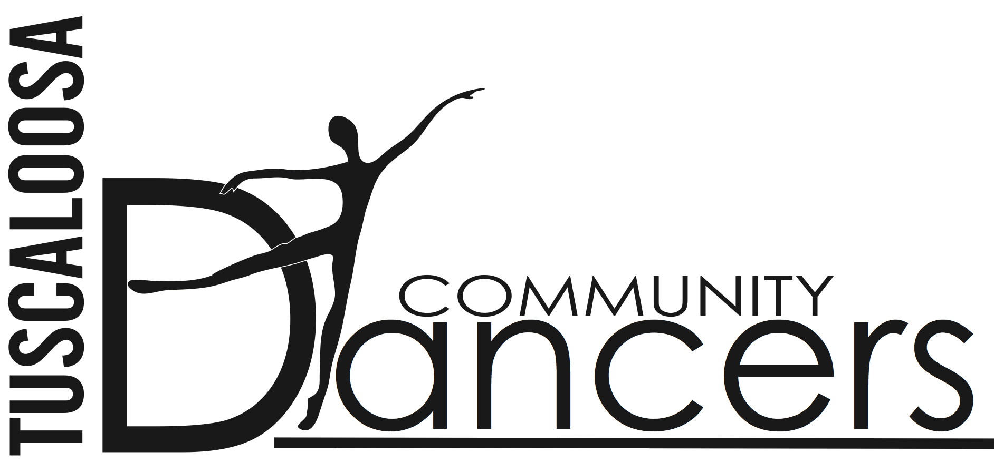
Tuscaloosa Community Dancers
P.O. Box 2665
Tuscaloosa, Alabama 35403
205.752.4220

30 August 2016

Since 1977, Tuscaloosa Community Dancers (TCD) has existed to promote the art of dance in the West Alabama community. Along with The Nutcracker, TCD produces an annual spring show, both works bringing guest artists from Alabama Ballet, the University of Alabama Dance Department, and professional dancers from all over the United States.
Not only do local dancers from every dance studio benefit from the expertise and dancing done with TCD, but school children from all over Tuscaloosa county attend our shows. Last March, we worked in conjunction with the Tuscaloosa Symphony to bring to life the music of CARNIVAL OF THE ANIMALS for hundreds of school children, and this December we are happy that The Nutcracker is the BAMA Fanfare show for Tuscaloosa Schools.
It costs approximately $40,000 to put on The Nutcracker at the historic BAMA Theatre, and the spring show can run equally as high, depending on the chosen piece. TCD’s annual budget is $90,000 without allowing for costume and set repairs, both of which we desperately need.
We would appreciate your financial support. Your contribution of $500, $1000, or $5000 or whatever you can give will enable us to continue to produce the outstanding productions the Tuscaloosa Community has come to expect. A contribution of $10,000 will underwrite one performance of The Nutcracker. Frankly, without your support this year, our ability to continue the program at its current level will be in jeopardy. Enclosed you will find the different levels of giving and the ways we will be able to publicly express our gratitude for your participation. We are a non-profit 501(c)(3) organization and all contributions are tax-deductible.
Thank you for your consideration. We can be reached at the TCD office by phone or email if you should have any questions.
Sincerely yours,
Joyce Phillips Becky Brewbaker
TCD Executive Director Fundraising Chairman
tcdancers@gmail.com

