Corporate Partner Pledge
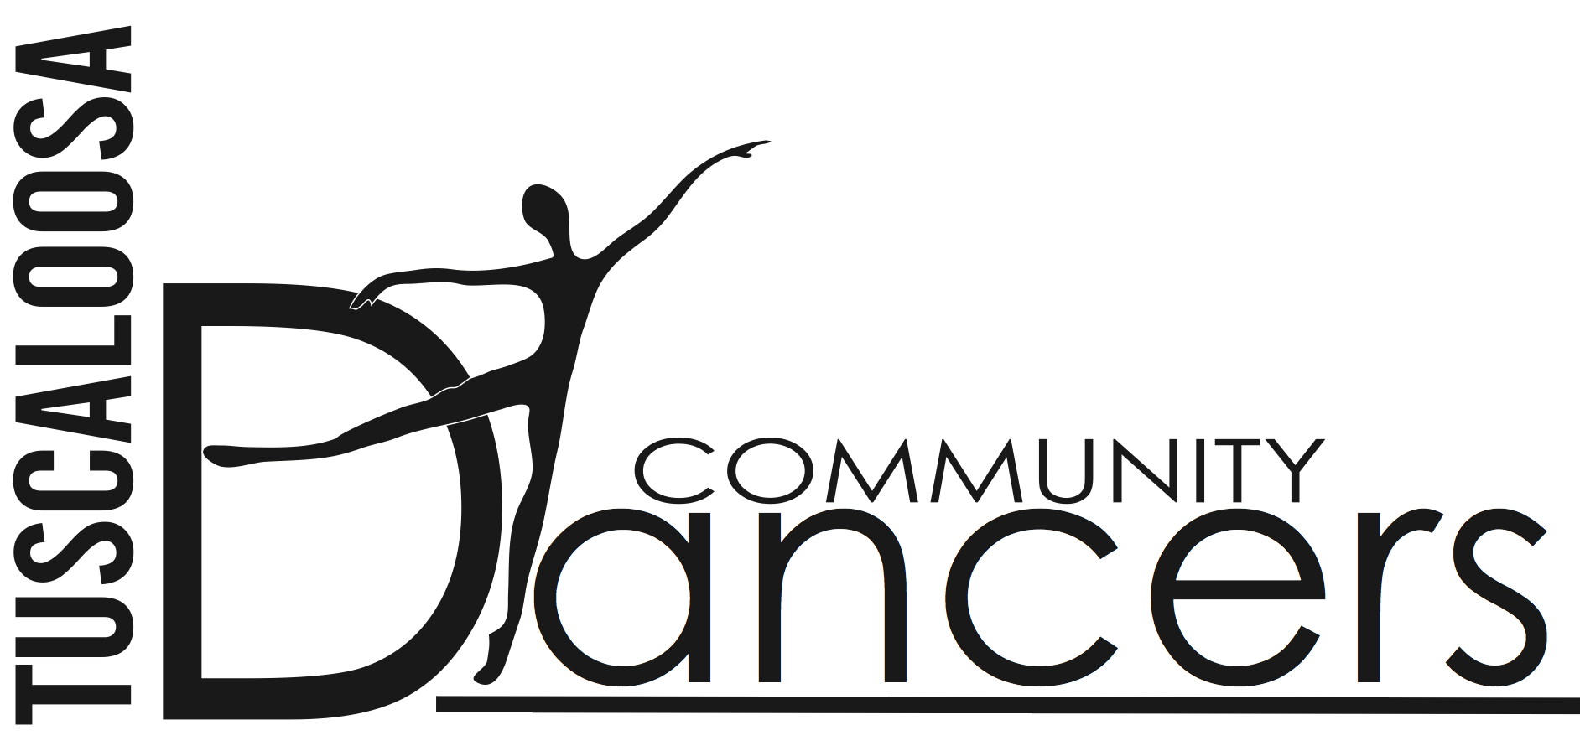
2016-2017 Dance Season

Company Name __________________________________________________________
Contact _________________________________________________________________
Address _________________________________________________________________
Phone ______________ Email _______________ Amount pledged ___________
Signature ________________________________ Date _________________

Please acknowledge our pledge at the following support level:
- $50-$199 Angel
Company name listed in the performance programs
- $200-$499 Corps
Benefits listed above, plus two complimentary tickets (upon request) to Nutcracker or Spring performance
- $500-$999 Soloist
Benefits listed above, plus two complimentary tickets (upon request) to Nutcracker and Spring performance and quarter page ad in the performance programs
- $1000-$2499 Principal
Benefits listed above, plus half page ad in the performance programs and name on posters
- $2500-$4900 Director’s Circle
Benefits listed above, plus 10 complimentary tickets (upon request) to Nutcracker and Spring performance, a full page ad in the performance programs and company name listed on performance posters
- $5000-$10,000 Season Partner
Benefits listed above, plus recognition as exclusive or co-sponsor of a single performance, and up to two rows of seating to your sponsored performance

TCD is a non-profit 501(c)(3) organization and all contributions are tax-deductible.
Please return this form to: Joyce Phillips, Executive Director
Tuscaloosa Community Dancers
P.O. Box 2665
Tuscaloosa, Alabama 35403
Phone: 205.752.4220 Email: tcdancers@gmail.com

